Infrastructure Setup : Semiconductor
Course Link : https://namaste-fpga.com/student/learn/105
My GitHub Infrastructure Setup Workflow and all stuff : https://github.com/ssbagi/Reusable-Chip-Platform
So, there is no CCI Violation at all. All the methods and understanding is Publicly available.
- Git Version Control
- Jenkins CI/CD

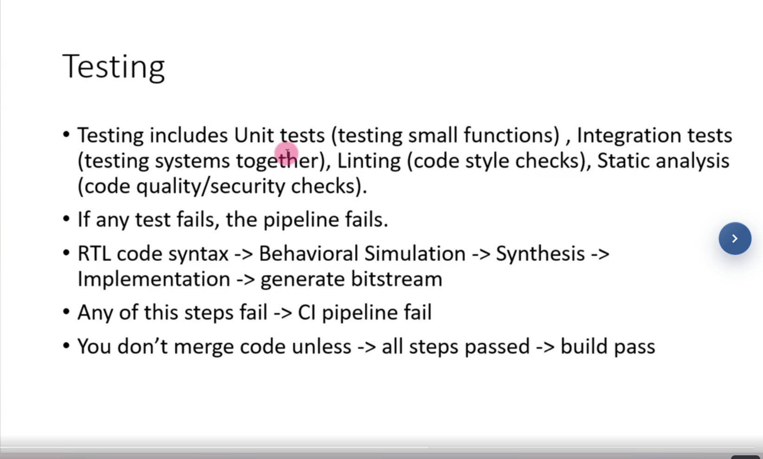

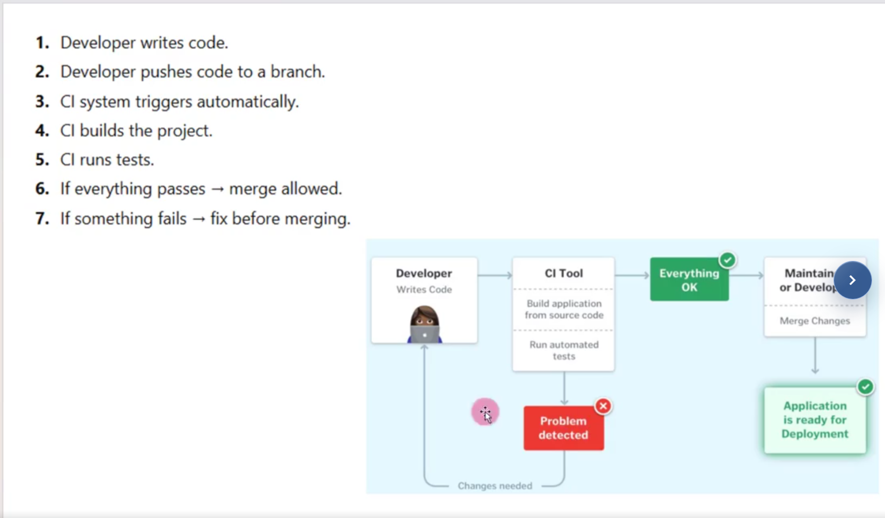

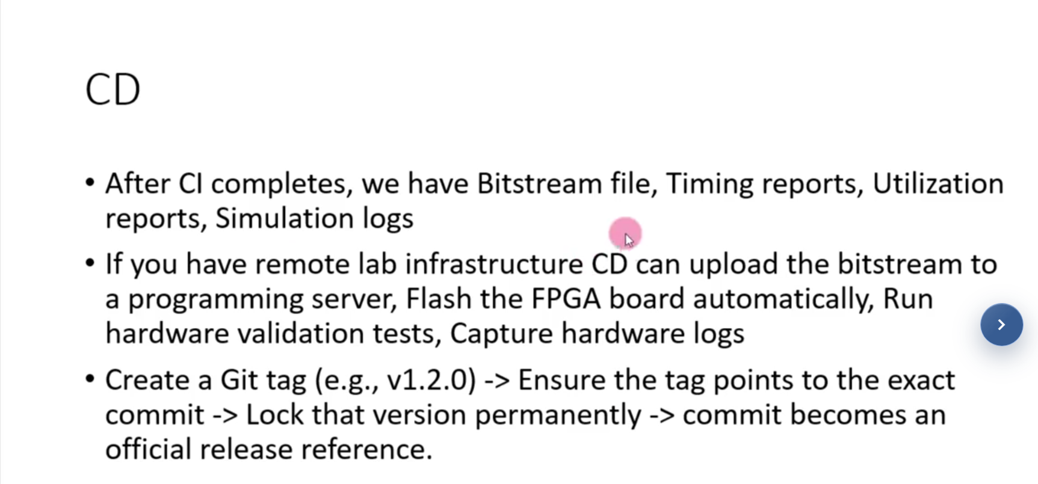

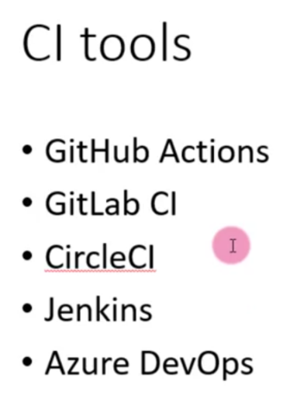

GitHub Flow Actions :

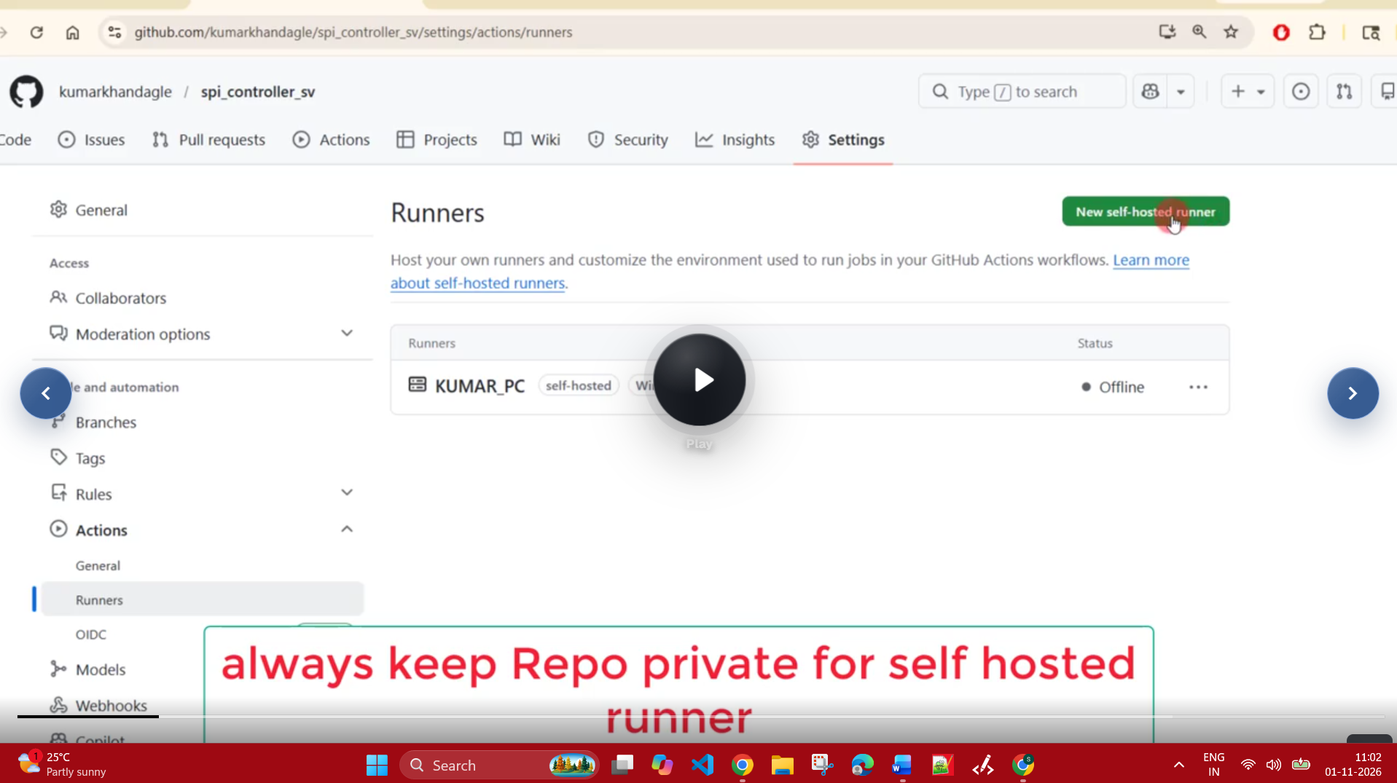

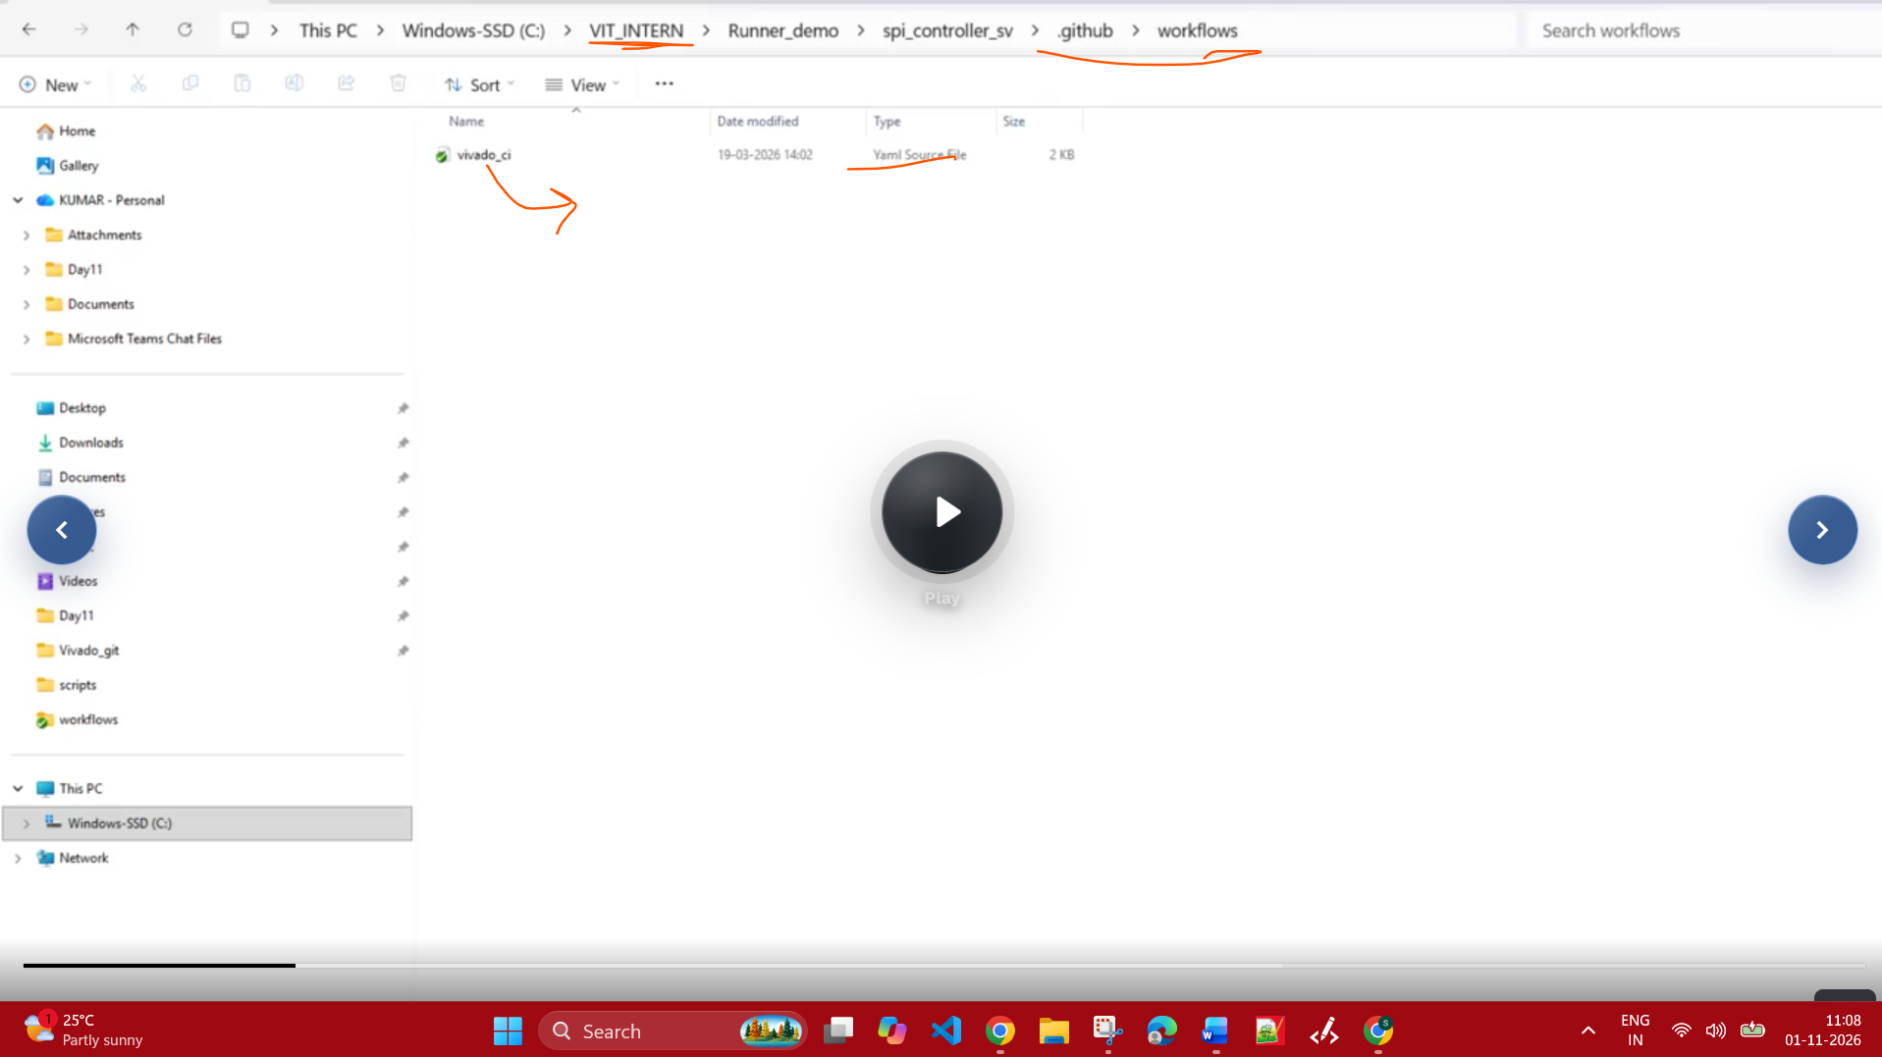

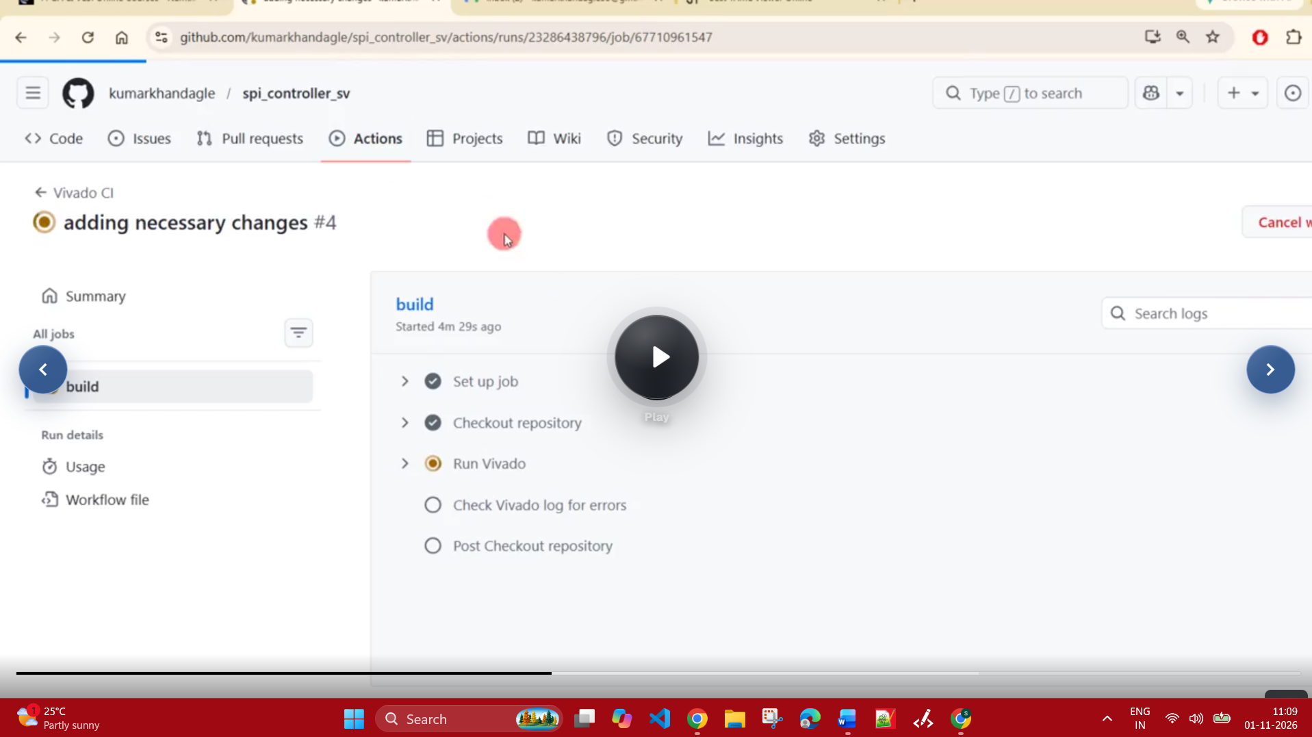

See it is already there : The way I showed the workflow concept stuff DL1, DL2 and DL3 or Leaf to Submodule to Block to SoC level and stuff.
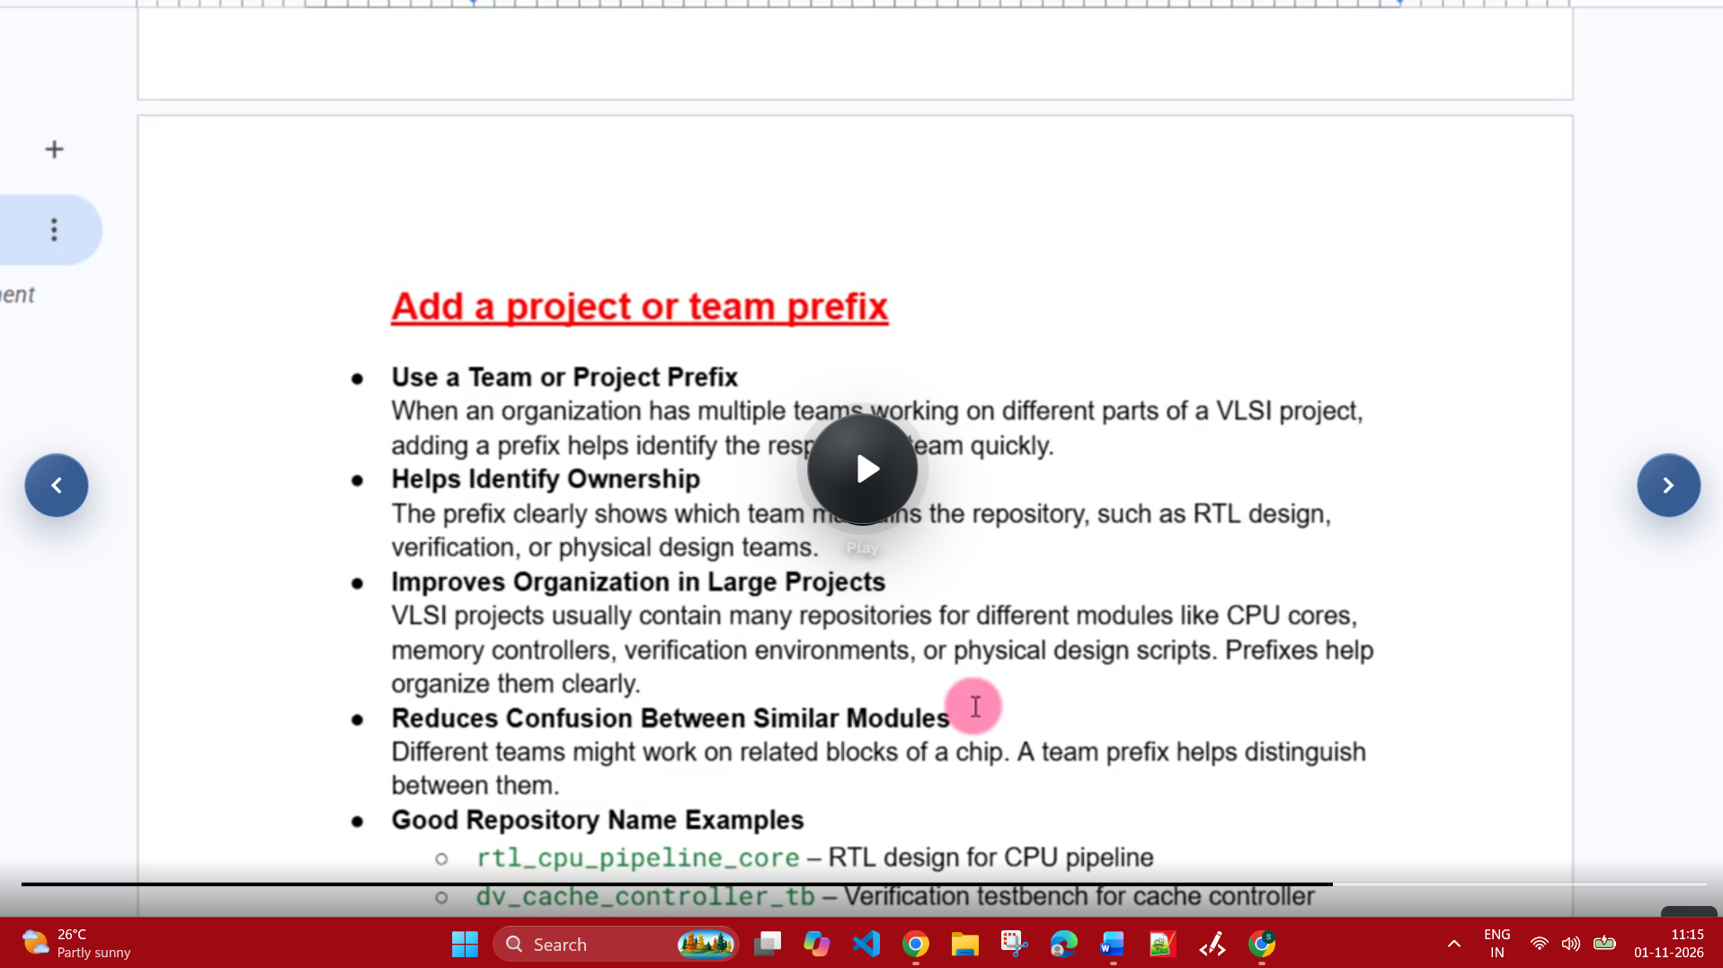

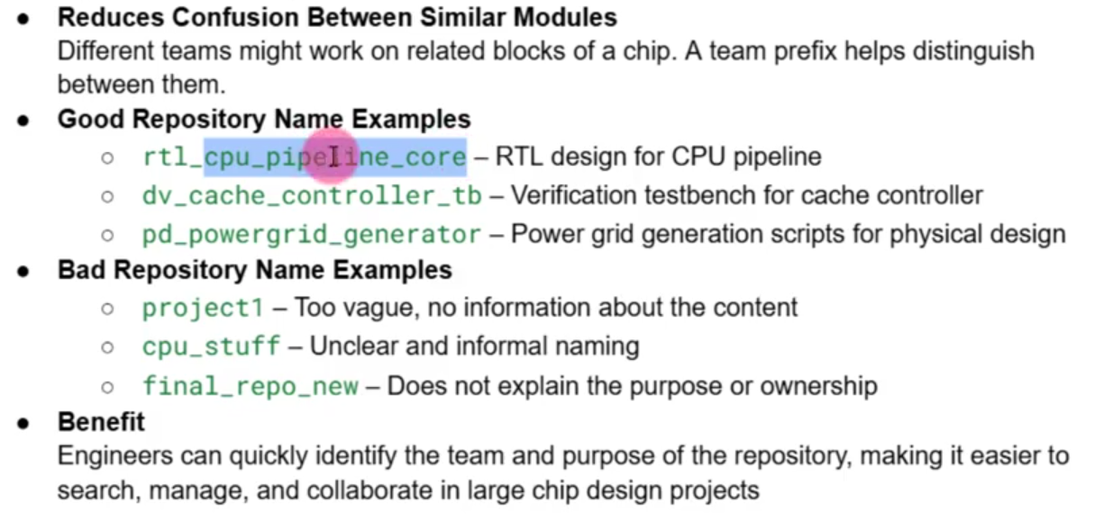

See even when I wrote the post on Friday, I mean the different frameworks learning and languages all are told or I mean existing ones only. Whatever I have said is entirely True and correct only.
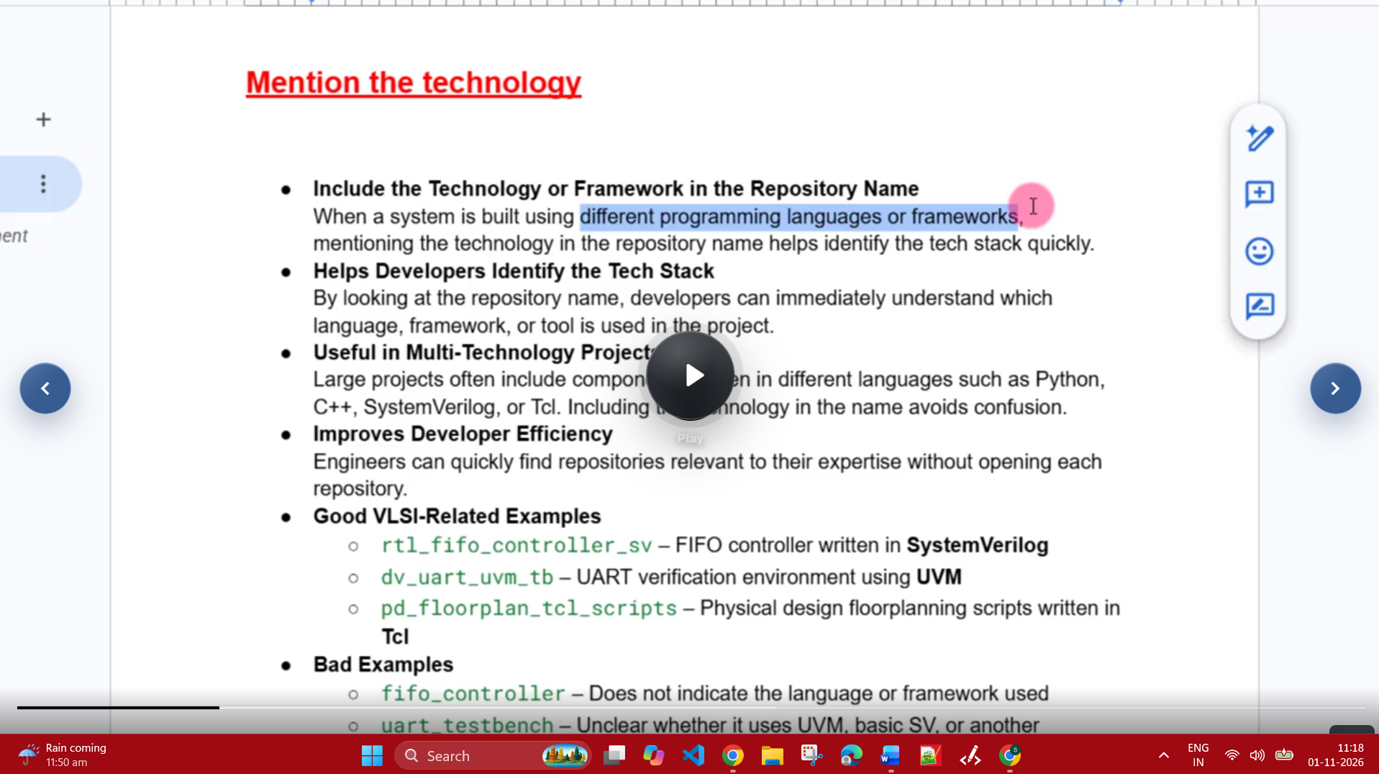

Version Control :
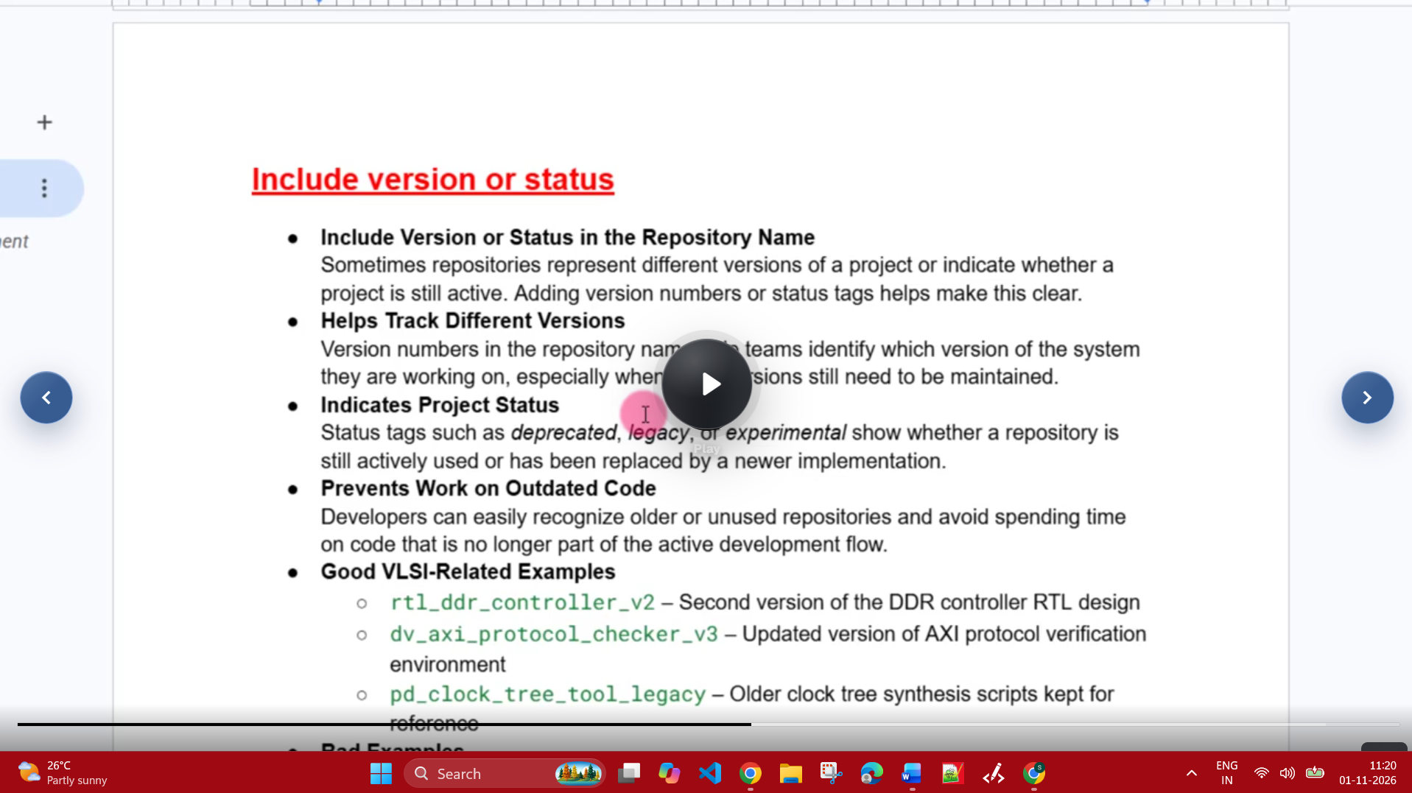

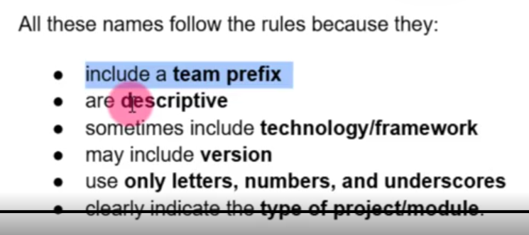

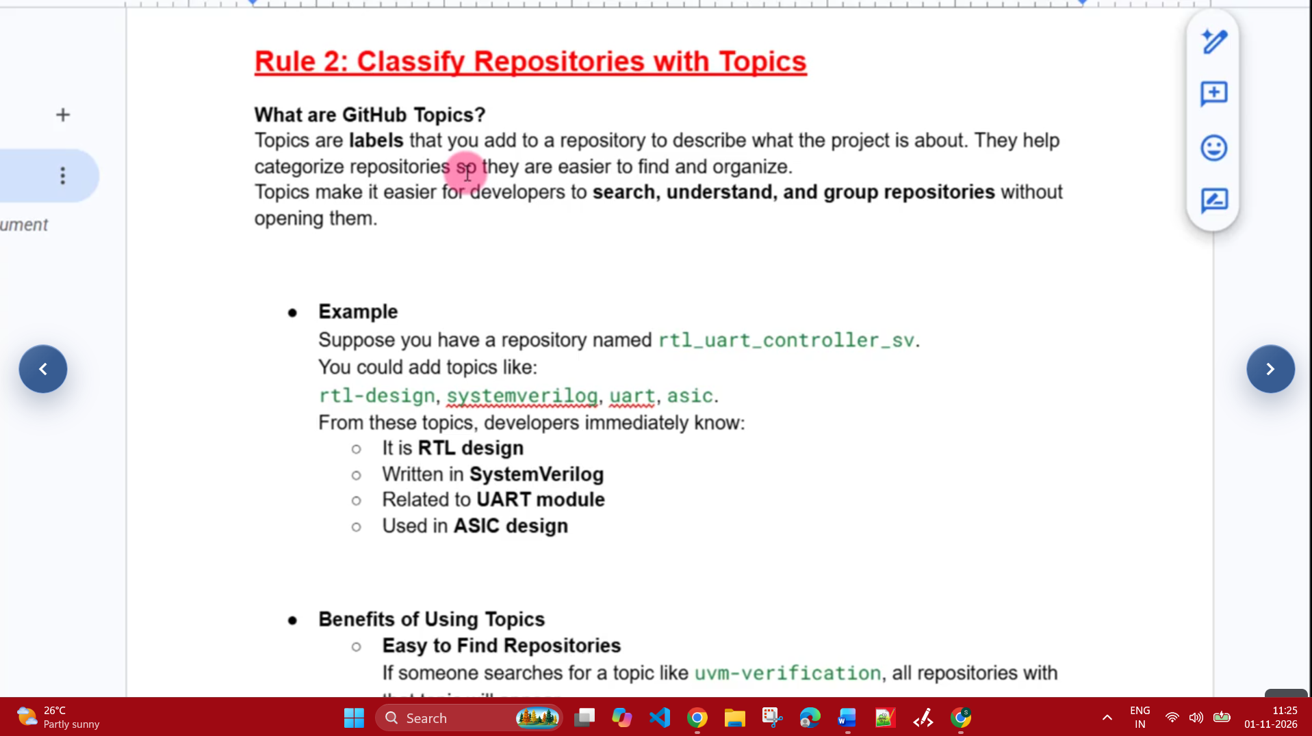

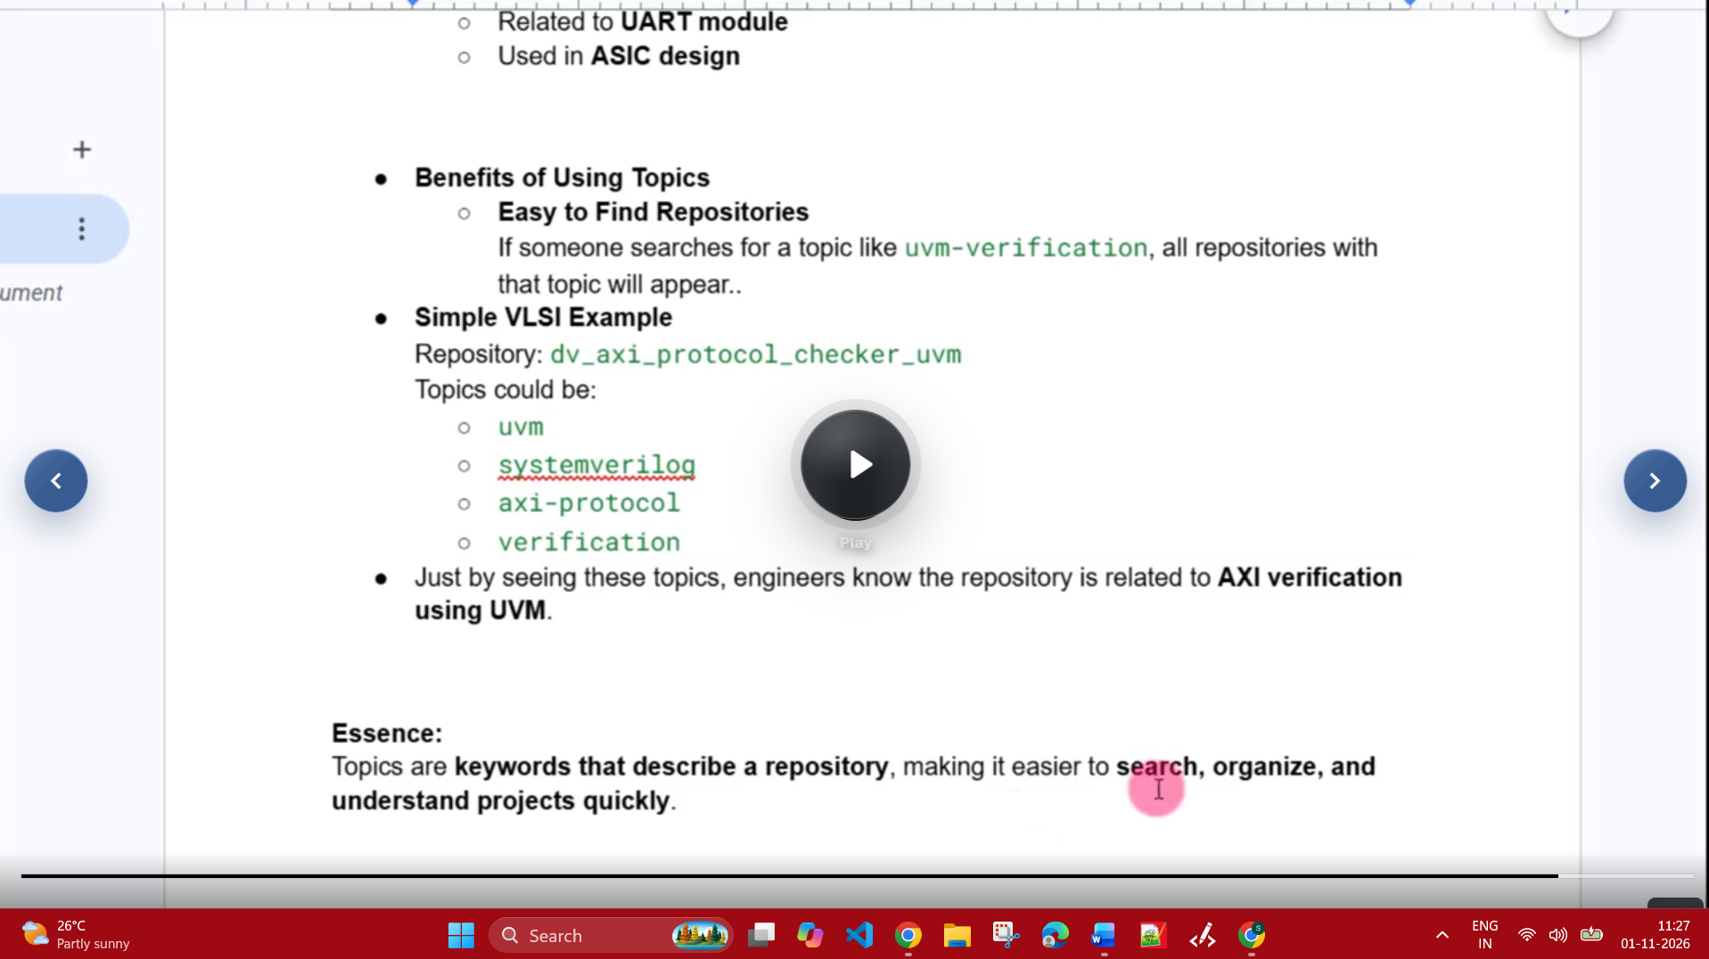

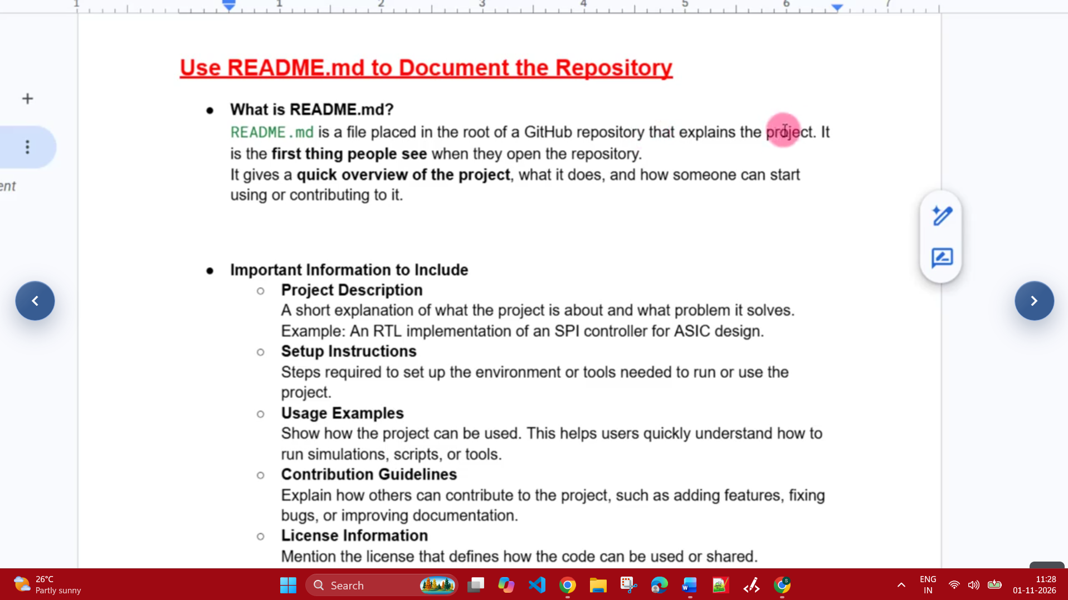

See even the directory structure also in the same way :



